BUSINESS ANALYTICS CASE STUDY REPORT
Customer Churn Analysis Using the IBM Telco Customer Churn Dataset
Prepared by: Damilola Owolabi
Internship: AnalystLab Africa Data Analytics Internship
Introduction
This project analyses the IBM Telco Customer Churn dataset to understand why customers leave the company. Using Power BI, I explored customer behaviour, identified the main factors linked to churn, and built an interactive dashboard to present the findings.
Business Problem
The company wants to understand why customers are leaving and which customer groups are most likely to churn. The analysis focuses on identifying the key drivers of churn and providing recommendations that can help improve customer retention.
Dataset Description
The IBM Telco Customer Churn dataset contains 7,043 customer records with information such as customer demographics, contract type, internet service, payment method, tenure, monthly charges, total charges, and churn status.
Data Preparation
Before the analysis, the dataset was cleaned in Power BI.
The following steps were completed:
- Checked for duplicate Customer IDs (none found).
- Found 11 blank values in the Total Charges column.
- Replaced the blank values with 0 because those customers had 0 months tenure.
- Verified data types.
- Created DAX measures and a Tenure Group column for reporting.
Data Analysis
The analysis focused on the factors most closely related to customer churn:
- Contract Type
- Tenure
- Internet Service
- Payment Method
- Technical Support
Power BI was used to create KPI cards and charts that made it easier to compare customer groups and identify patterns.
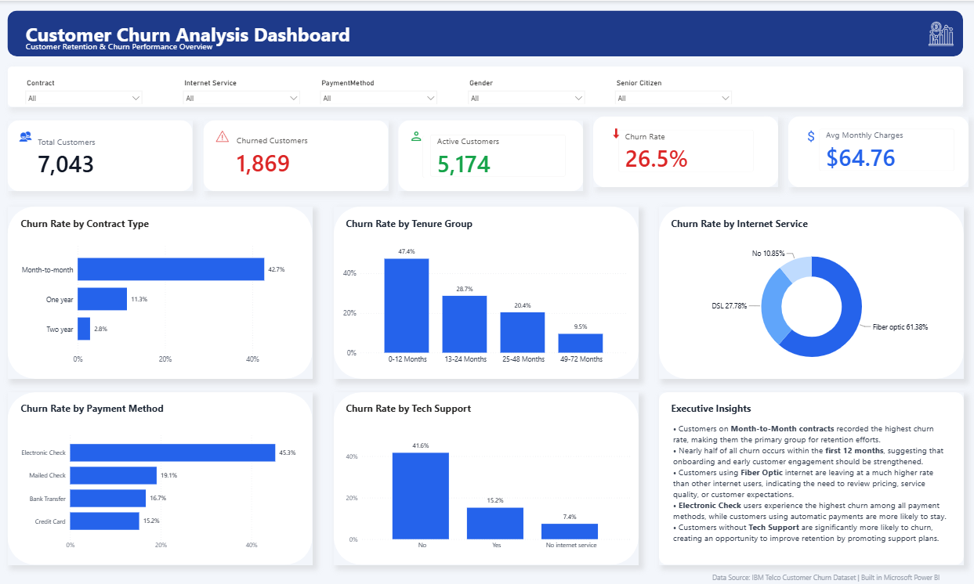
Figure 1. Customer Churn Dashboard created in Microsoft Power BI
Key Findings
The analysis showed that the overall churn rate was 26.5%.
Customers on Month-to-Month contracts recorded the highest churn, while customers on longer contracts were more likely to stay.
Customers with 0–12 months tenure had the highest churn, showing that newer customers are more likely to leave.
Among internet service types, Fiber Optic customers recorded the highest churn.
Customers using Electronic Check had the highest churn compared to other payment methods.
Customers without Tech Support were also much more likely to leave than those receiving technical support.
Business Insights
The results suggest that customer churn is mainly driven by contract type, customer tenure, internet service, payment method, and technical support. Customers in their first year and those on flexible contracts require the most attention, as they represent the highest risk of leaving.
Recommendations
- Introduce retention offers for Month-to-Month customers.
- Improve customer onboarding during the first year.
- Review the Fiber Optic service to identify possible issues.
- Encourage customers to switch to automatic payment methods.
- Promote Tech Support services to customers who do not currently subscribe.
Conclusion
This project identified the main factors contributing to customer churn and presented the findings in an interactive Power BI dashboard. The insights and recommendations can help the company improve customer retention and support better business decisions.

